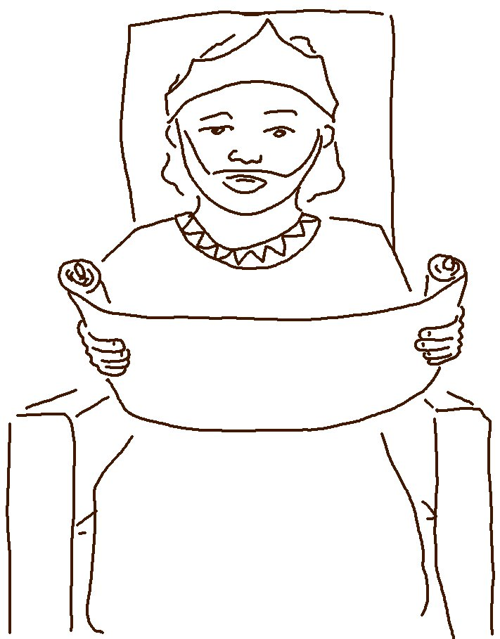

If you love me, obey my
commandments. John 14:15_{NLT}

